Here is an introduction to the fundamental concepts of computer networks.

## What is a Computer Network?

A computer network is a collection of two or more computers, servers, mainframes, mobile devices, or other computing devices (like printers or scanners) that are connected together. This connection allows them to communicate with each other and share resources.

The most famous example of a computer network is the **Internet**, which connects millions of computers worldwide.

## Core Components of a Network

Every network, regardless of its size, is built upon a few basic components:

1. **Nodes:** These are the devices on the network. Examples include:
   * **End Devices:** Computers, smartphones, printers, servers, and smart TVs. These are the devices that users interact with directly.
   * **Network Devices:** Hardware that connects the end devices and manages the flow of data. This includes switches, routers, and wireless access points.
2. **Links (Media):** This is the pathway data travels on. It can be:
   * **Wired:** Using cables like Ethernet (twisted-pair) or fiber optic cables.
   * **Wireless:** Using radio waves, such as Wi-Fi or Bluetooth.
3. **Protocols:** These are the rules or languages that govern communication between devices. Just as two people need to speak the same language to understand each other, two devices need to use the same protocol.
   * A common example is the **TCP/IP** (Transmission Control Protocol/Internet Protocol) suite, which is the foundation of the internet.

## Why Use a Network?

Networks exist to make things more efficient. The primary benefits include:

* **Resource Sharing:** Allows many users to share a single piece of hardware (like a printer or scanner) or software (like a shared database).
* **Communication:** Enables people to communicate easily via email, video conferencing, instant messaging, and more.
* **File and Data Sharing:** Makes it simple to access and share files stored on other computers or central servers.
* **Centralized Administration:** In a business, a network allows for easier management, security updates, and software installation from a central location.

## Types of Networks (By Scale)

Networks are often classified by their geographical size.

### LAN (Local Area Network)

A **LAN** covers a small geographical area, such as a single home, office building, or school campus.

* **Characteristics:** Typically high-speed, privately owned, and managed.
* **Technology:** Most modern LANs use Ethernet (wired) and Wi-Fi (wireless).

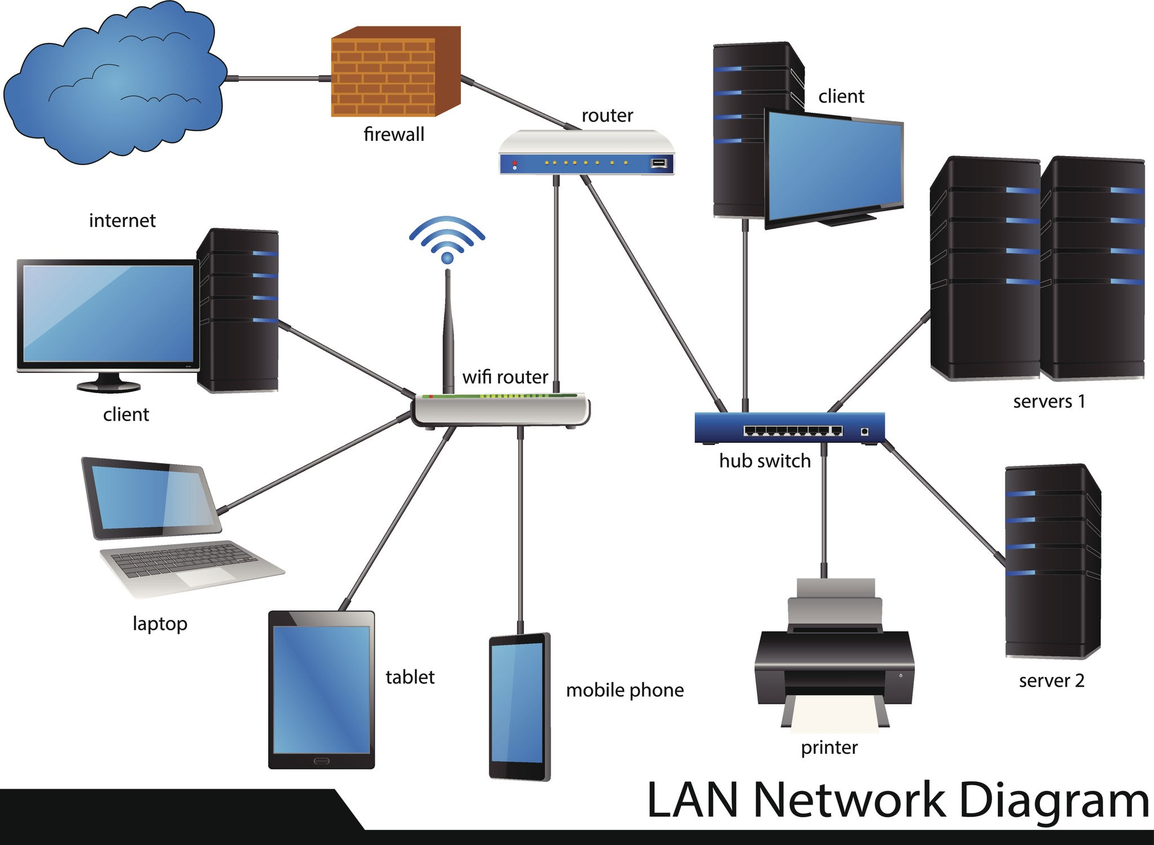

Getty Images

### WAN (Wide Area Network)

A **WAN** spans a large geographical area, such as a city, country, or even the entire globe. A WAN is essentially a network of LANs connected together.

* **Characteristics:** Slower than LANs, often managed by multiple service providers (like telecom companies).
* **Example:** The **Internet** is the largest WAN. A company connecting its New York office to its London office would be using a WAN.

## Network Topologies

Topology refers to how the nodes and links in a network are physically or logically arranged.

* **Star Topology:** All devices are connected to a central hub or switch. This is the most common topology used in LANs today. If one device fails, the rest of the network is unaffected (unless the central switch fails).
* **Bus Topology:** (Older) All devices share a single common cable (the "bus").
* **Ring Topology:** (Older) Each device is connected to exactly two other devices, forming a ring.
* **Mesh Topology:** Every device is connected to every other device. This is very reliable (if one link fails, data can take another path) but expensive and complex to set up. The core of the internet uses a partial mesh topology. [Image comparing Star, Bus, and Mesh network topologies]